Name ________________________________________________________________________ Ast# ________

Inner Space Unit Review Sheet

Vocabulary:

atoll
barrier reef
continental drift
continental rise
continental slope
convection current
crust
delta
fault
fjord
fringing reef
guyots
hot spot
hydrothermal vent
island arcs
keys (cays)
magma
mantle
mid-ocean ridge
plate tectonics
plates
rift valley
seafloor spreading
seamounts
subduction
submarine canyons
topography
trenches

Know the following:
1. The theory of Plate Tectonics and Continental Drift hypothesis. All.The.Stuff about them and the players involved.

2. What the asthenosphere and lithosphere are, what they are made up of, how they behave, and what they do.

3. Describe the processes of subduction and effects of.

4. What the materials are like under the crust.

5. What you can find at rift zones under the ocean. Describe what is there.

6. All about different reefs and their formation.

7. Islands, seamounts, guyots

8. What is this diagram all about below? Know about the evidence that supports seafloor spreading!!! Hint: the bands below.

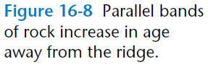
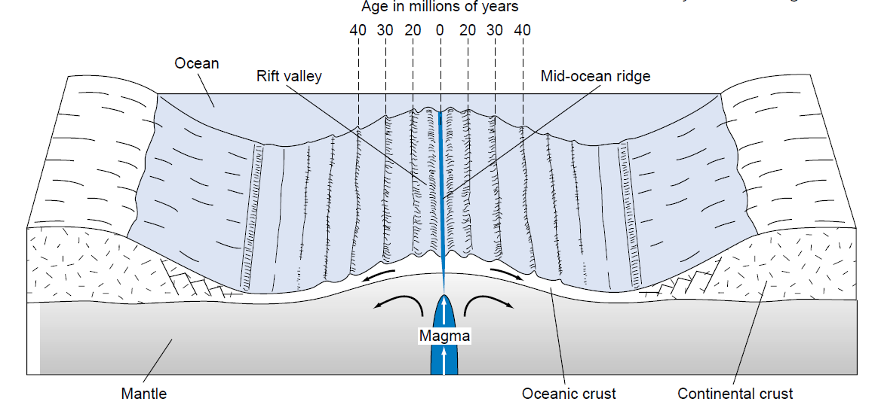

9. The classification of shorelines (coastlines) and examples of each one (what is a delta, fjord, submarine canyon).

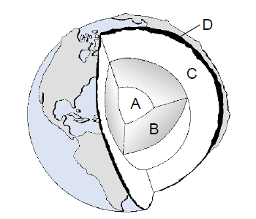
10. This.

11. How to calculate depth using sonar data!!

12. What this is…
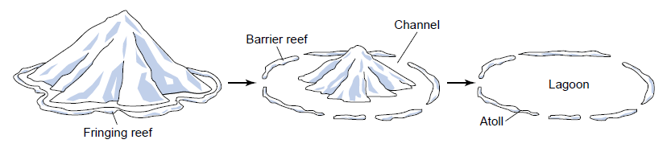
13. All about ocean floor profiles and the features there. See below – LABEL!! This one can be tricky!!

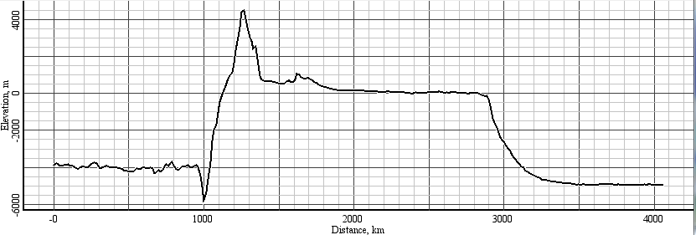

14. Where all the water on our planet came from.

15. The effects of erosion on coasts.

Anything… anything in Ch. 16 Greene is fair game!! Get those notes done.

*This sheet is extra credit if there are notes/answers filled in!!!! Basically, if it looks like you actually used it to help you with the unit test.

